|  |
| --- |
| Group 89 |
| Usability Testing Method Release 2 |
| Pinelands Academy of Music |
|  |

|  |
| --- |
|  |

Table of Contents

Introduction 1

Test participants 1

Scenario 1 – Sign Up 1

Resolution 1 2

Browse PAoM Teachers List 3

Resolution 2 3

Browse and Hire Instruments 4

Resolution 3 5

Create a Booking 6

Resolution 4 7

Edit Profile and View Bookings 7

Resolution 5 7

Conclusion 8

# Introduction

The testing method used was Hallway Testing; this involves test participants who are not trained in website usability testing. This method was chosen as it will give feedback in real time using an audience that will most likely be similar to future customers. I will be using a shadowing technique whilst the participants try to navigate the website with the scenario given.

# Test participants

|  |  |  |
| --- | --- | --- |
| Name | Age | Computer Literacy (1-10) |
| Keegan Tessier | 10 | 7 |
| William Matterson | 21 | 9 |
| Jodi Hanson | 33 | 5 |
| Jane Bickford | 46 | 3 |
| John Gedge | 63 | 8 |

All of the test users are all avid users of the internet but their literacy/tuition in regards to technology as a whole vary but should not impact the scenarios given to them. Keegans mother was also invited to simulate the parent or guardian assisting in creating an account for someone under the age of 16.

# Scenario 1 – Sign Up

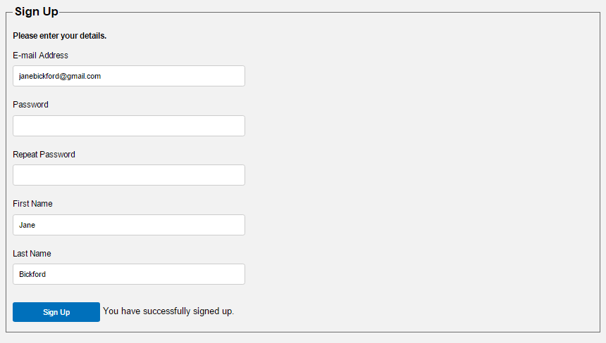

|  |  |
| --- | --- |
| Name | Feedback |
| Keegan | Keegan was able to quickly find the Sign Up tab and start the process of creating his account. Filling the guardian/ parent filled was also a simple process. |
| William | Easily able to locate the Sign Up tab and create an account. |
| Jodi | Easily able to locate the Sign Up tab and create an account but made a remark about how subtle the sign up confirmation was. |
| Jane | Found the Sign Up tab easily enough, traced the mouse left to right to find the tab. Once all the fields for account creation were filled she failed to realise the account had been created via the You have successfully signed up next to the Sign Up button. |
| John | Easily able to locate the Sign Up tab and create an account but took a few seconds to register the account had been successfully created. |

# Resolution 1

It has been made apparent by test participants that when an account is successfully created it must be more apparent to the user. Creating a pop up with the account confirmation would make it highly visible and force the user to acknowledge it was a success.

# Browse PAoM Teachers List

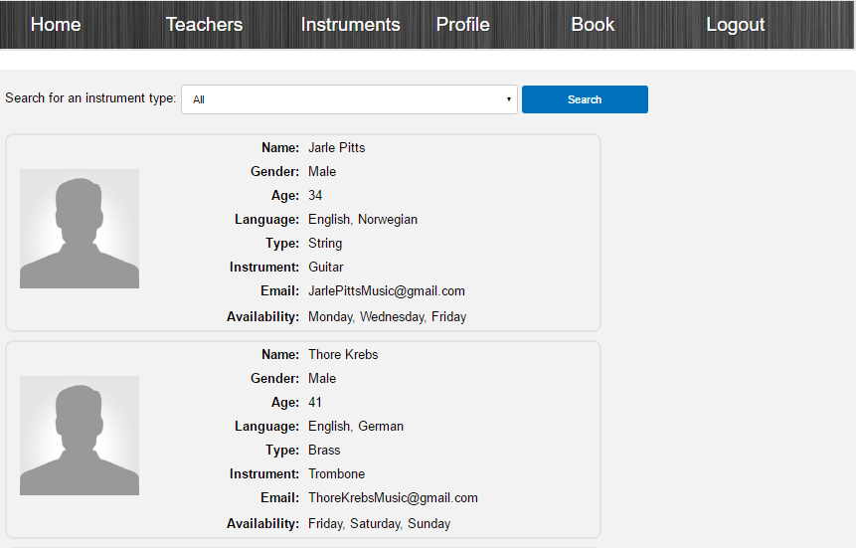

|  |  |
| --- | --- |
| Name | Feedback |
| Keegan | The teacher list was located in a more than acceptable time frame and Keegan was able to navigate and sort through the different teacher types. |
| William | Found the Teacher tab quickly and filtered the different teacher types with ease but stated he would like the email to be a link. |
| Jodi | Found the Teacher tab quickly and filtered the different teacher types with ease. |
| Jane | Found the Teacher tab quickly and filtered the different teacher types with ease. |
| John | Found the Teacher tab quickly and filtered the different teacher types with ease. John made the comment that he would like the email addresses linked and that it would require less jumping if there was a direct booking link on the teachers profile. A link either on their available days or a booking button in their profile capsule. |

# Resolution 2

The participants have suggested linking for the emails of the teachers to create less work for the user and create a better experience. Johns comment also made sense in having the availabilities link to the calendar to make the booking experience as easiest as possible. The easier to book the better, this would lower users not completing a booking by not understanding the process. Simplicity is the key.

# Browse and Hire Instruments

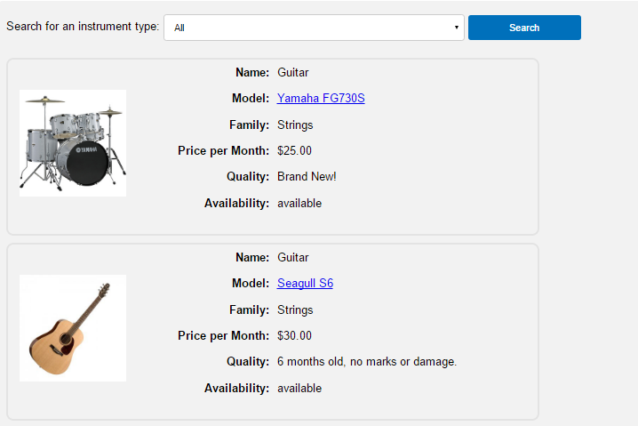

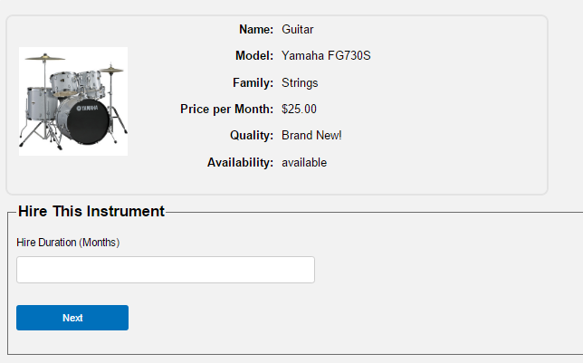

|  |  |
| --- | --- |
| Name | Feedback |
| Keegan | The instrument list was easily located but stated he didn’t know where the hyperlinked instrument name would take him. Keegan found the rest of the process to be simple. Keegan would like for more pictures of the instruments. |
| William | Found the Teacher instrument tab quickly and blindly hit the hyperlink hoping it would take him to the hire page. William said it wasn’t obvious how to get the hire page. William found the rest of the process to be a simple task and stated the payment page was very similar to other websites he had used. |
| Jodi | Jodi was familiar with the simple layout and could find the instrument tab but scrolled up and down the page to hire the instrument. Jodi failed to realise the instrument name would take her to the next step of booking. I had to intervene and move her to the next step. After the initial confusion Jodi could finish hiring an instrument with comfort. |
| Jane | Jane had a similar problem to Jodi and could not figure out how to move to the next step once landing on the instrument page, intervention was needed once again. The rest of the process of hiring an instrument was simple for Jane but she commented that she would’ve liked to see the cost of the instrument broken down monthly and then the total cost stated. |
| John | Located the instrument tab easily but scrolled up and down the page looking for a hire button, clicked the link to see where it would take him. John completed the rest of the scenario but mentioned that he’d like the interface to be easier to navigate and an option to save his payment method. |

# Resolution 3

It has been made painfully obvious that it is confusing to all test participants with a varying degree of computer literacy that the current hiring system is not intuitive and hard to navigate. This problem can be alleviated easily by having a clear and distinct hire button within the instrument capsule. Saving payment information would make the hiring process a simplistic task for repeat customers but is currently not able to happen in this phase of development due to security reasons. It is a valid recommendation and could be seen in future releases. The addition of more pictures that would be in a rotating fashion is a great idea but this release focused on functionality rather than cosmetics.

# Create a Booking

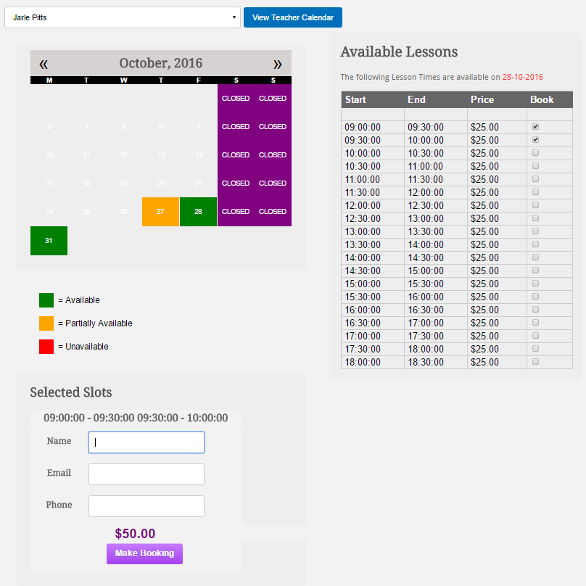

|  |  |
| --- | --- |
| Name | Feedback |
| Keegan (String Hire) | Keegan ran into a problem early not remembering the instruments the teacher specialised in. Keegan opened a new tab and quickly solved the problem. The rest of the booking process was hassle free. |
| William (Bass Hire) | William forgot the teacher’s specialised instrument and opened a new tab to find out, he commented that the instruments need to be listed with the names in the drop down list. |
| Jodi (Keyboard Hire) | Jodi ran into the same problem that the previous two test subjects faced. Jodi did not open a new tab slowing the process down but was able to complete the task with ease. |
| Jane (Woodwind Hire) | Jane experienced the same problem as the others but could make a booking without a problem. |
| John (Percussion Hire) | The final test participant John did the same thing as the others and had to open a new tab but once he knew what teacher was needed he completed the scenario. John commented that having to enter the name, email and phone was a redundant step as he was already logged in with the same credentials. |

# Resolution 4

There was a repeat problem with all of the test users in regards to them not knowing what instruments the teachers taught. The instruments must be place next to the teachers name or a filter to find the teachers you want on the booking page. The comment made before about having booking links on the teachers profiles would also alleviate this problem.

# Edit Profile and View Bookings

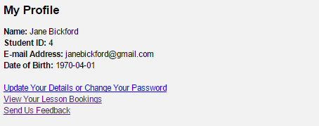

|  |  |
| --- | --- |
| Name | Feedback |
| Keegan | Able to easily navigate to the profile page and view bookings, Keegan was able to view his bookings without problem also. |
| William | Able to easily navigate to the profile page and find his booking. William commented that he would like for an option to cancel or alter the booked time. |
| Jodi | Found the Profile tab easily but stated she only knew that the View Your Lesson Books was a link due to the previous one she found on the website. |
| Jane | Located the Profile tab with ease but stated she only knew that there was links in the Profile due to them all being clustered together. Did not like that bookings could not be altered. |
| John | Navigated to the Profile tab and proceeded to the bookings without hassle. John mentioned he would like to see an option to export the bookings to a calendar on his phone and to be able to alter bookings. |

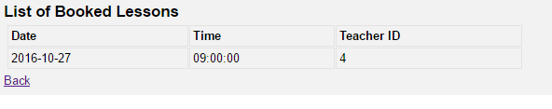

## Resolution 5

There is a need for more features for the current booking system. A majority of the test participants stated they wanted more functionality in regards to bookings they had made. The current system would force users to call and have someone alter their bookings. The pages within the Profile tab must be made more apparent to the user to minimise confusion.

# Conclusion

The test participants have identified issues with the websites user interface. UI changes must be made in future releases and a consistent design of buttons and navigate must be throughout the website to create a less confusing user experience. It was satisfying to witness the test participants being able to use the features within the website easily for the most part.